Comprehensive Analysis and Dietary Strategies with Tableau: A College Food Choices Case Study

# INTRODUCTION

* 1. **Project Overview**

"Comprehensive Analysis and Dietary Strategies with Tableau: A College Food Choices Case Study" is a data visualization project focused on analyzing the dietary trends, habits, and health indicators of college students. It leverages Tableau to create interactive dashboards and stories, aiming to support educational institutions in promoting student well-being.

* 1. **Purpose**

The purpose of this project is to provide stakeholders with actionable insights into college students' eating behaviors using real-time data visualizations, enabling informed decisions, nutritional awareness, and effective interventions.

# IDEATION PHASE

### Problem Statement

College students often face dietary imbalances due to irregular routines, limited food options, and lack of awareness. This affects their physical and academic performance. There is a need to analyze and visualize these patterns effectively.

### Empathy Map Canvas

*Think:* "How can I stay healthy with my tight schedule?" *Feel:* Concerned about poor nutrition. *Say:* "I don't have time to cook." *Do:* Eat out, skip meals, prefer comfort food.

### 2.2 Brainstorming

* Use Tableau for data visualization
* Collect and clean dietary data
* Create real-time dashboards
* Enable predictive analytics
* Address dietary deficiencies

## REQUIREMENT ANALYSIS

### Customer Journey map

User (student) logs dietary data → Data processed → Visualized in Tableau → Insights generated → Health decisions influenced

### Solution Requirement

* + - Dataset with food habits, exercise, perceptions
    - Tableau Desktop/Public
    - Web integration with Flask (optional)

### Data Flow Diagram

Data Collection → Data Cleaning → Tableau Visualization → Dashboard/Story → Insights/Decisions

### Technology Stack

* + - Tableau
    - Python (Flask for web)
    - Google Drive/CSV for data storage

## PROJECT DESIGN

### Problem Solution Fit

The proposed dashboard addresses the lack of visibility into students' nutrition habits by transforming raw data into usable insights.

### Proposed Solution

Interactive Tableau dashboards showing metrics like calorie consumption, exercise frequency, favorite foods, and comfort food reasons.

### Solution Architecture

CSV Dataset → Tableau (data import) → Clean/Prepare Data → Create Visualizations → Assemble Dashboard/Story → Publish to Tableau Public

## PROJECT PLANNING & SCHEDULING

### Project Planning

* + - Week 1: Dataset Collection & Cleaning
    - Week 2: Tableau Setup & Initial Charts
    - Week 3: Dashboard Design
    - Week 4: Story Creation & Publishing
    - Week 5: Report Writing & Demo Recording

## FUNCTIONAL AND PERFORMANCE TESTING

### Performance Testing

* + - Number of visualizations: 10+ unique charts
    - Filters: Gender, Cuisine, Exercise, Income, etc.
    - Real-time responsiveness tested
    - Calculation fields: Calorie totals, averages, frequency counts

## RESULTS

* 1. **Output Screenshots**

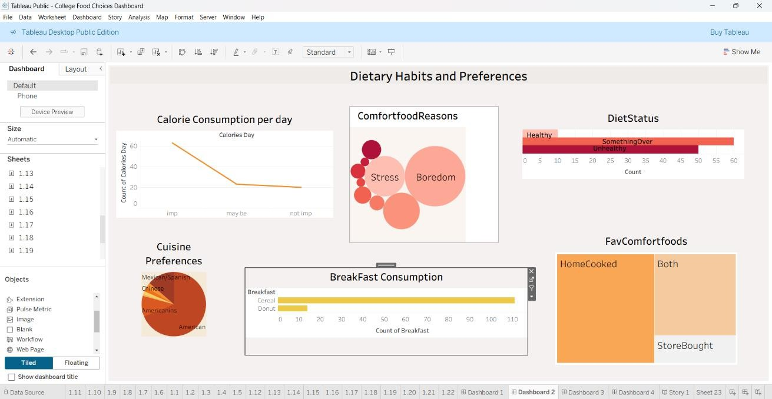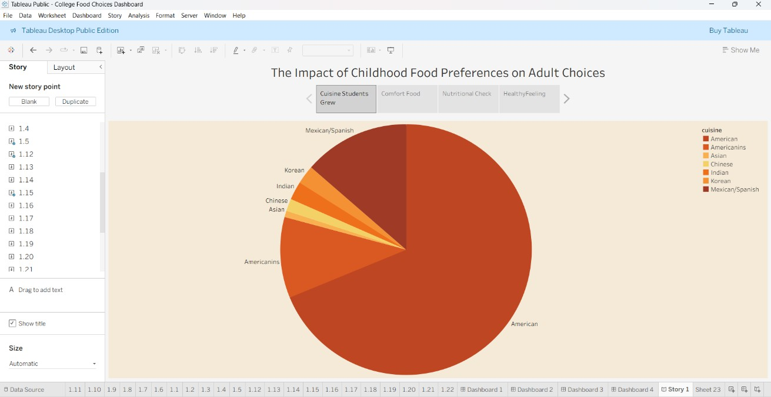

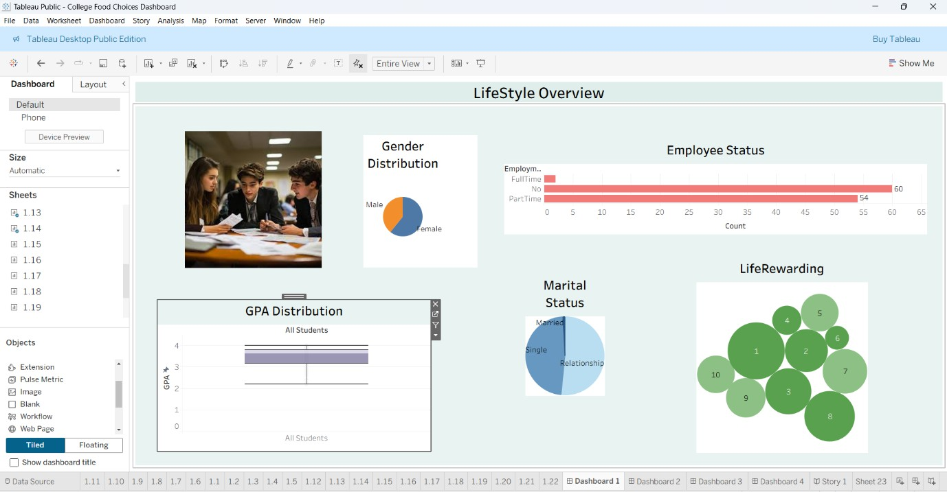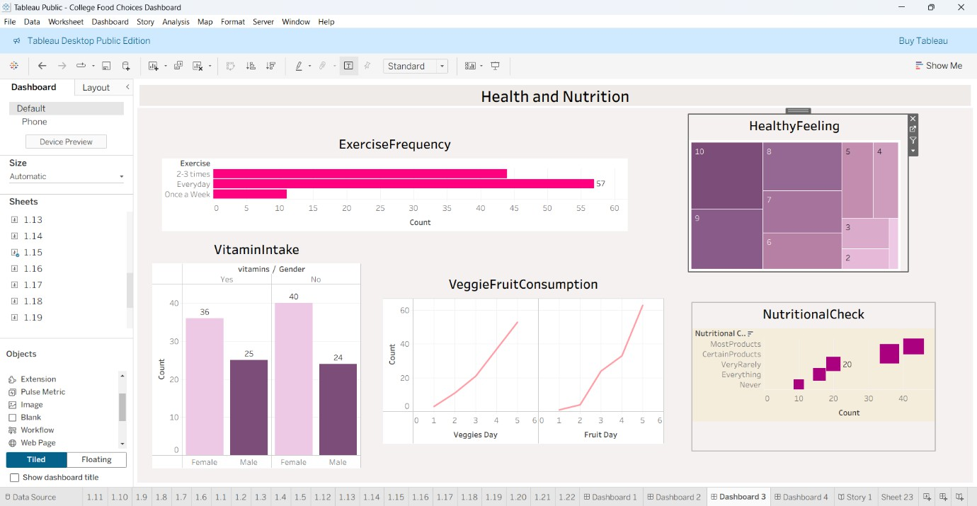

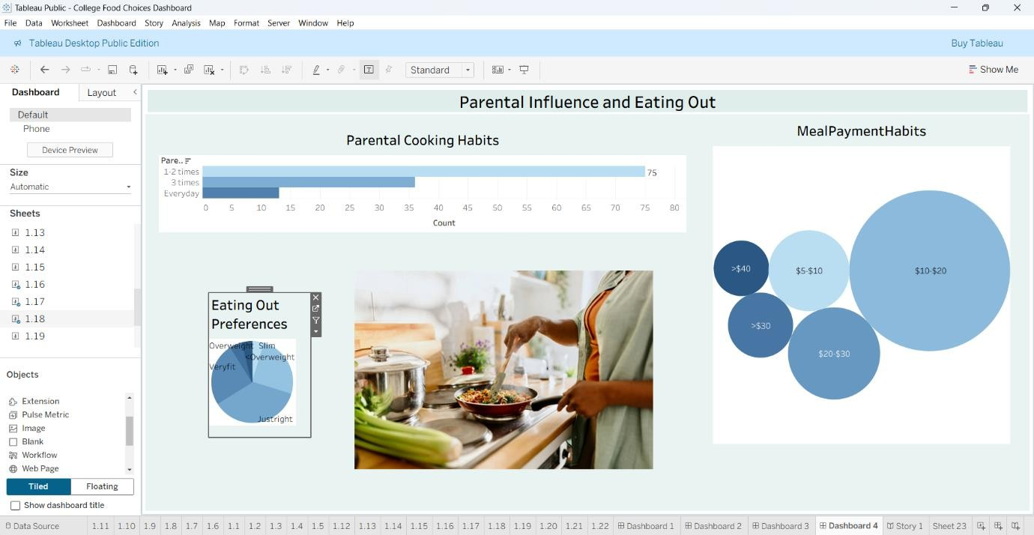

## ADVANTAGES & DISADVANTAGES

### Advantages:

* Visual clarity
* Real-time insight generation
* Interactive filtering

### Disadvantages:

* Requires cleaned data
* Tableau Public has feature limits

## CONCLUSION

This project effectively uses Tableau to identify trends in college dietary habits and promotes better health through data-driven strategies. Institutions can leverage this to create awareness and tailor food offerings.

## FUTURE SCOPE

* Integrate with real-time food tracking apps
* Include mental health correlations
* Mobile-compatible dashboards

## APPENDIX

**Source Code (if any):** Flask code for dashboard embedding (not included here)

### App.py

from flask import *

app = Flask( name )

@app.route("/") def home():

return render_template("index.html")

if name == " main ":

app.run(debug=True, port=1212)

### index.html

<!DOCTYPE html>

<html>

<head>

<title>College Food Choices Case Study</title>

</head>

<body style="text-align:center; font-family:sans-serif;">

<h1 style="color:red;">A COLLEGE FOOD CHOICES CASE STUDY</h1>

<!-- Embed Tableau Dashboard -->

<iframe

src="https://public.tableau.com/app/profile/kadali.anjali/viz/CollegeFoodChoicesDashboard/Sto

ry1"

width="1000" height="800">

</iframe>

</body>

</html>

**Dataset Link:** https://[www.kaggle.com/datasets/borapajo/food-choices?select=food_coded.csv](http://www.kaggle.com/datasets/borapajo/food-choices?select=food_coded.csv)

**GitHub & Project Demo Link:** https://github.com/23pa5a0505/vishnu-varshitha-Smart-Intenz/tree/main